NOTIFICATION API
After creating the Rabbit MQ in the orderphase 2 api, and executing it, then you can start the Notification API.
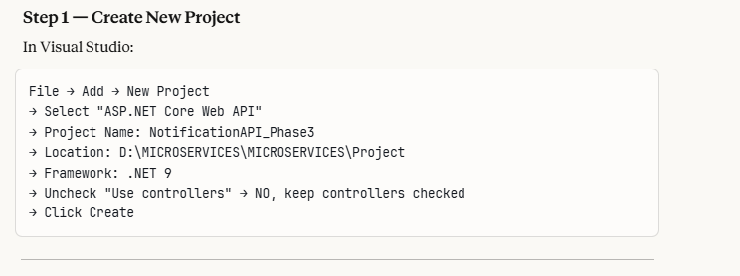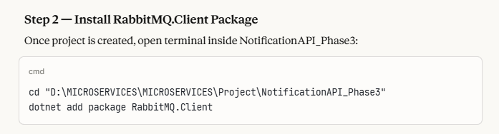
STEP 3 – SET PORT TO 5003
"applicationUrl": http://localhost:5003
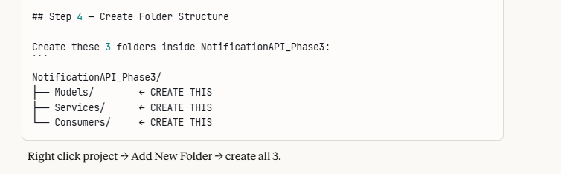

MODELS FOLDER
- Create a class named “OrderCreatedEvent.cs”
- This class should have then properties as same as the “orderevent created” in the order API, orderevent model class.
- Because ,once when the order is placed, it sends the json to the rabbit mq, then that message with the same property names will be sent to the notification api, so property names should match.

SERVICES FOLDER
- Create a class named “NotificationService.cs”
- This handles the actual notification logic
- Refer the summary mentioned in this class file for detailed explanations.
- This logic you can replace as like sending email once when the order is placed in real scenario

CONSUMERS FOLDER – BACKGROUND RUNNING TASK
- A .net class that runs continuously in the background from the moment your app starts until it is shut down.
- It’s only job is to listen to RabbitMQ queue and process messages

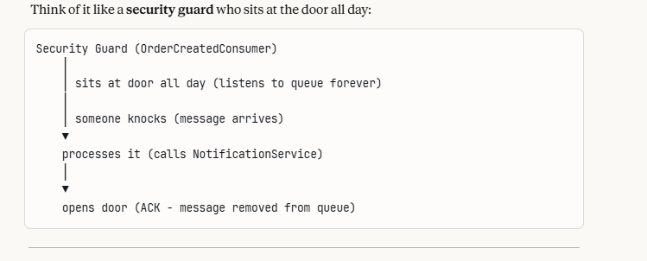
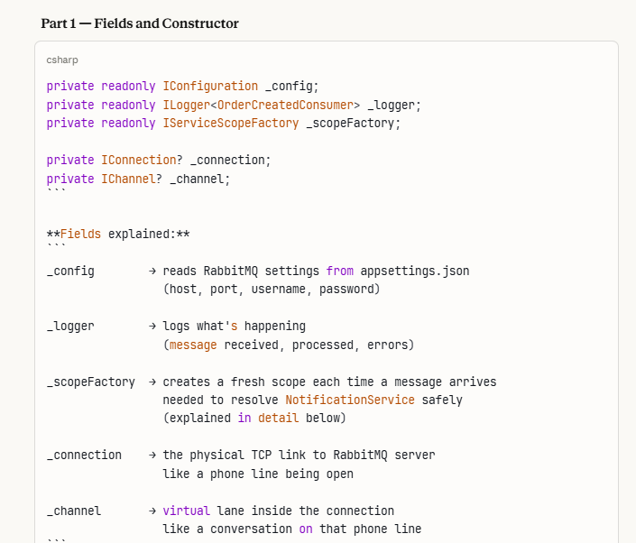
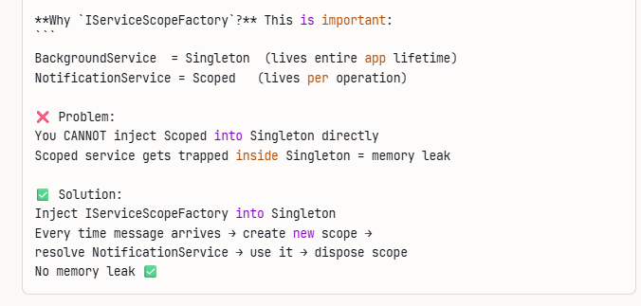
Part 2 – StartAsync()- Run once on App start
- This method runs once when your app starts. It does these 5 things
- Read RabbitMQ settings from appsettings.json
- Create connection (TCP link to rabbitmq)
- Create channel (virtual lane inside connection)
- Declare exchange + queue + binding
(same as Order.API – idempotent, safe to repeat)
- Set prefetchCount=1 (process one message at a time, fair dispatch)
Why declare Exchange/Queue again here?
Order.API declares them when it starts (publisher side) Notification.API declares them when it starts (consumer side)
RabbitMQ is idempotent:
"If exchange/queue already exists with same settings → do nothing"
"If it doesn't exist yet → create it"

This means Notification.API can start BEFORE Order.API and the queue will still exist ✅

Part 3 – ExecuteAsync() – The Listening Loop

- This is the **heart of the class**. It runs forever until app stops.

- 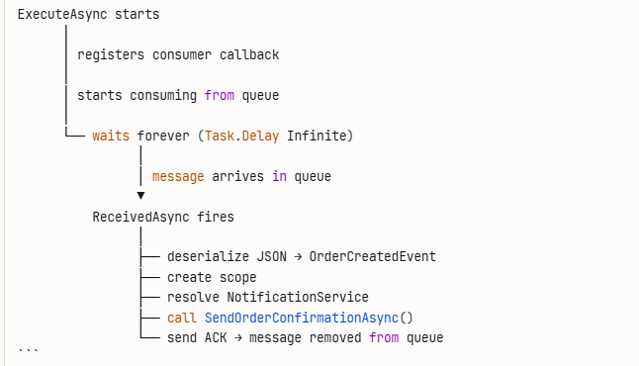

- Inside the callback, 3 scenarios:

- Scenario 1 — Happy path:
Message arrives → deserialized → notification sent → ACK
✅ RabbitMQ removes message from queue
- Scenario 2 — Null message:
Message arrives → deserialization returns null → ACK
anyway We acknowledge it to remove garbage from queue
- Scenario 3 — Exception thrown:
Message arrives → something crashes → NACK sent
requeue: false → message goes to Dead Letter Queue
We don't retry forever on persistent errors

Why `autoAck: false`

autoAck: true → RabbitMQ deletes message the MOMENT it delivers it even if your code crashes while processing = DATA LOSS ❌

autoAck: false → YOU manually send ACK after successful processing if code crashes → no ACK sent → message stays in queue → redelivered when service restarts = SAFE ✅

Part 4 – StopAsync() – Cleanup on Shutdown

Runs when app is shutting down:
- When this method is called
- It closes the channel
- It closes the connection
- It logs “disconnected”
- This is a clean shutdown, no abrupt disconnection from rabbitmq

Full lifecycle
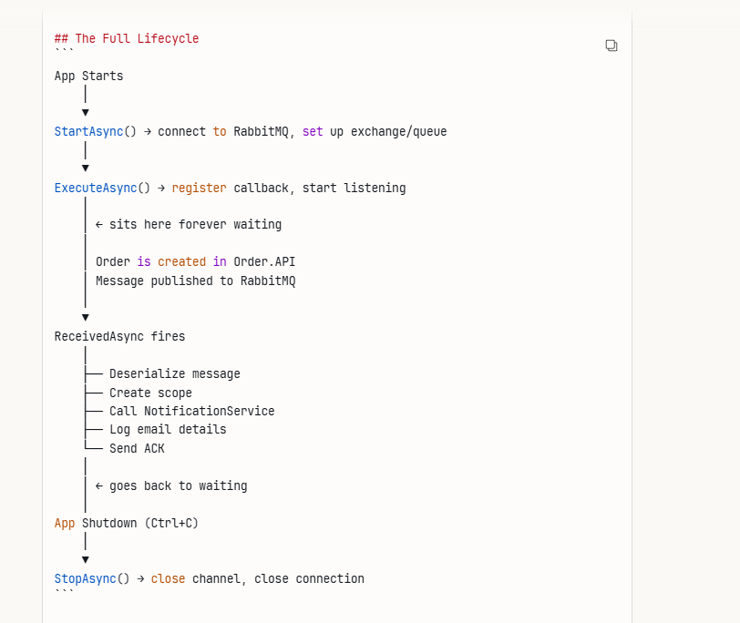
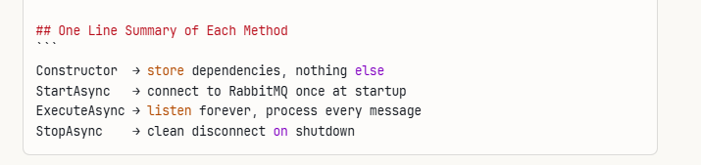

After creating the notificatoinservice.cs , then move to the program.cs and appsettings.cs

- In appsettings.json , give the rabbitmq connection string

Notification.API = background listener only
no HTTP endpoints
no controllers
no Swagger needed ✅

- Now run the notification api and check the rabbit mq , there will be 2 connections
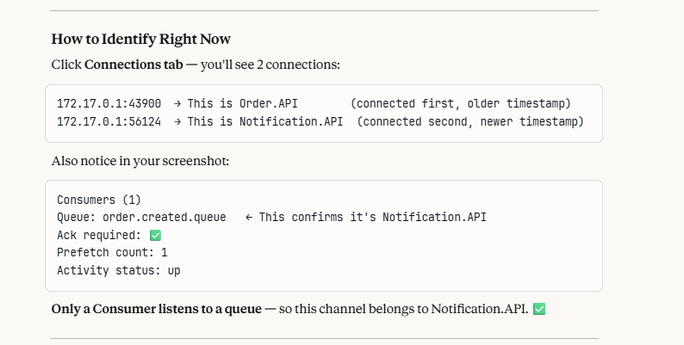

Below is the command prompt of the console window which comes when we run the notification api, it shows listening on queue- order.created.queue

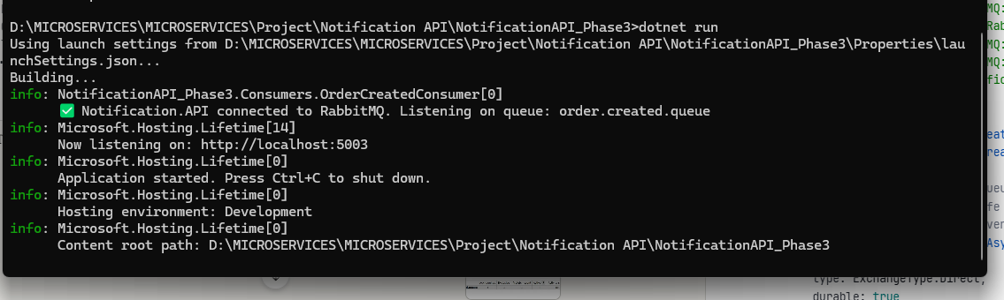

REAL SCENARIO TEST OF RUNNING THE APPLICATION ORDER API, PRODUCT API, NOTIFICATION API

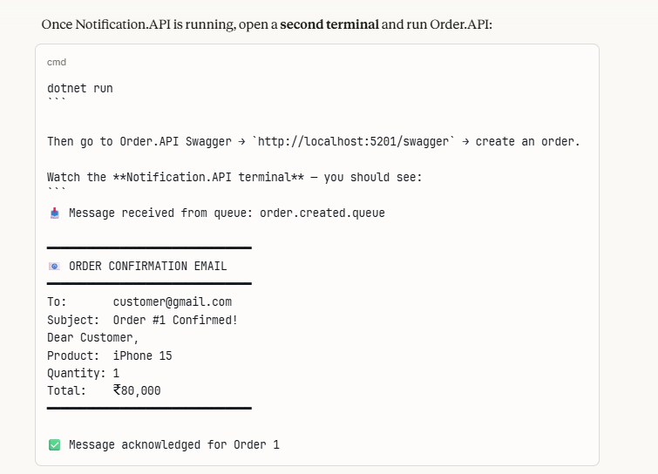

- First run product API, Order API , for a time being don’t run the Notification api
- Now in swagger, create an order (note that notification api is not running) so we can see the message in the queue of the order created
- Now open the order api swagger and give the product details as a user who want to make an order
- Now go and check the rabbit mq, “Queues and streams” tab menu option
- In that table click the “order.created.queue”
- You will see the “GetMessage” button
- Click this button , you will see the order that has been placed in the swagger” in order api, in the payload you can see the order details,
- 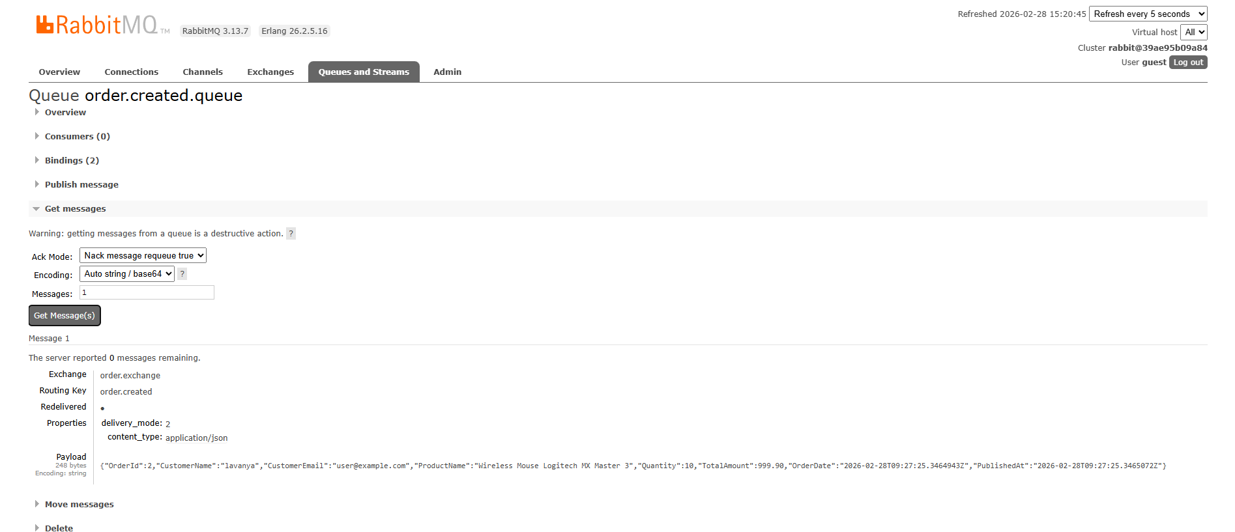

- Now when the notification api is not running, what you do is now run the notification api.
- Now the concept is , the order was in the queue when the notification api was not running , as soon as the notificationapi runs , the message from the queue is removed because it has been delivered. This is the concept, you can again check the rabbit mq “Get message” menu option, you will see the “queue is empty”,the below shows what happens when the app is run

- 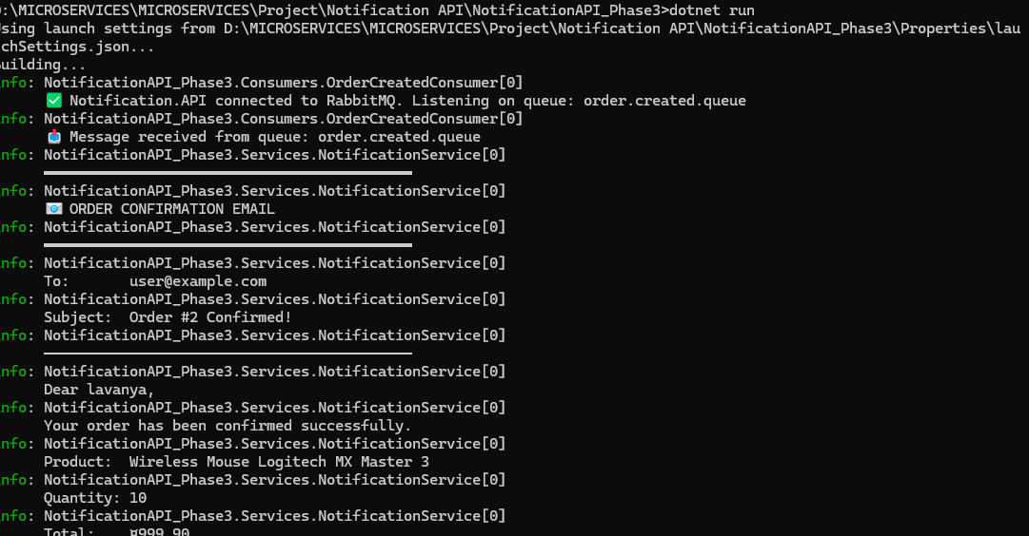
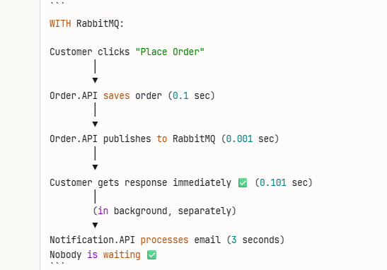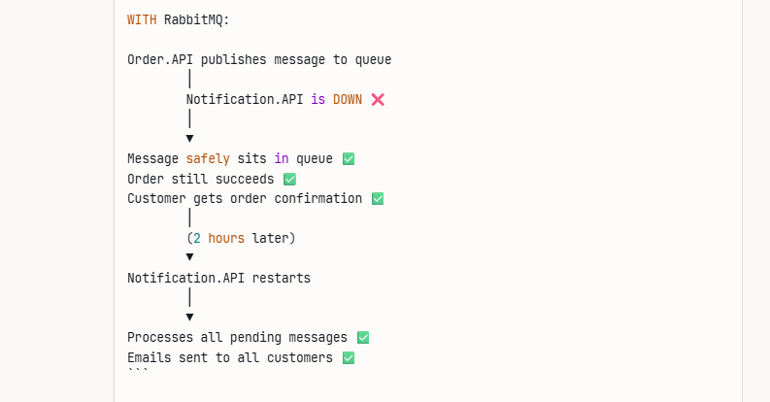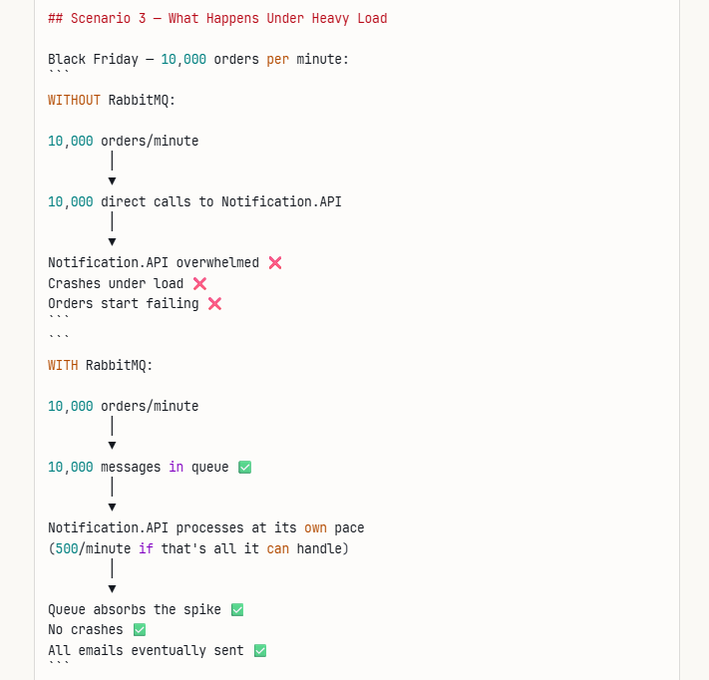

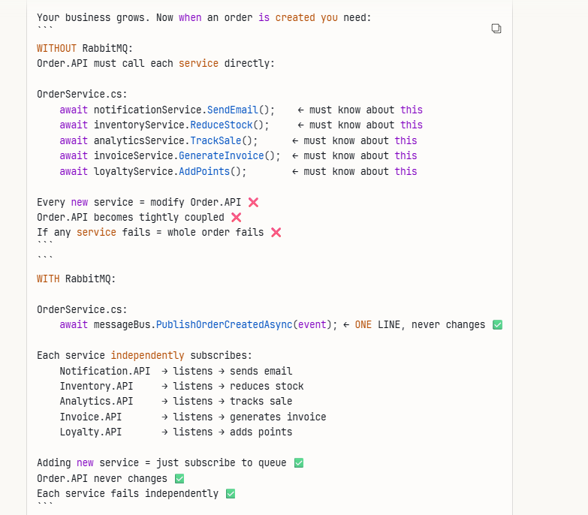

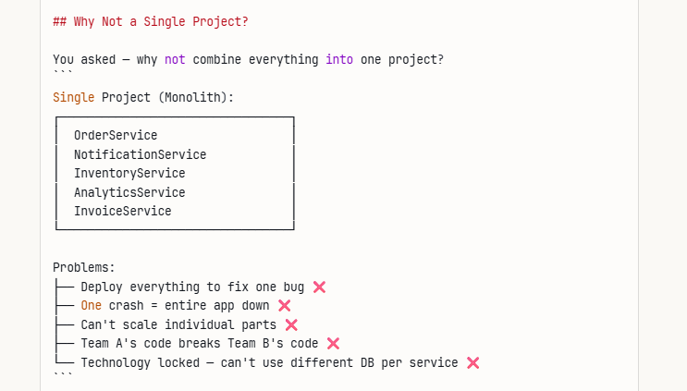

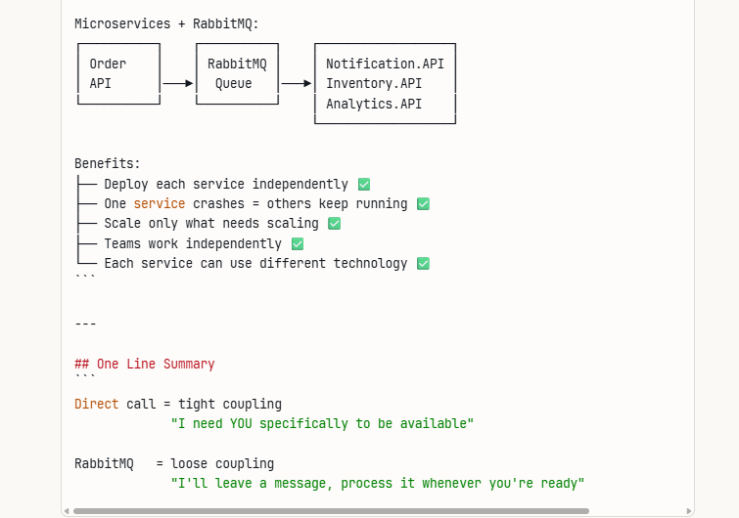

NEXT PHASE 4 – API GATEWAY WITH OCELOT – REFER THE SEPARATE WORD FILE OF “OCELOT GATEWAY NOTES”

